SECTION 5
MEIDA AND CONVERTER

🔌 Copper Media — Characteristics, Capabilities & Applications
(CompTIA Network+ N10-009 aligned — nothing omitted)

📜 IEEE 802.3 Ethernet Standard
- Defined by IEEE
- Governs wired Ethernet networking
- Covers:
  - Physical Layer (Layer 1)
  - Data Link Layer – MAC sublayer (Layer 2)
- Used primarily in Local Area Networks (LANs)
- Defines:
  - Cable types
  - Signaling methods
  - Speeds
  - Distances
  - Frequencies
Under IEEE 802.3, supported media includes:
- Twisted pair copper
- Coaxial copper
- Twinaxial copper
- Direct Attach Copper (DAC)
- Fiber optics (mentioned but not covered in this lesson)
This lesson focuses only on copper media.

🧵 Twisted Pair Cables
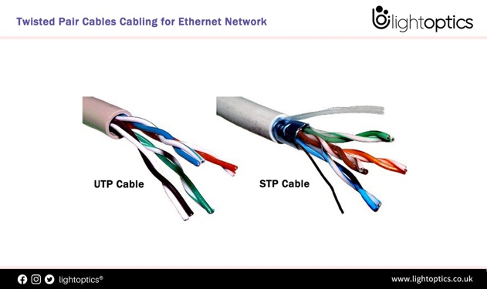
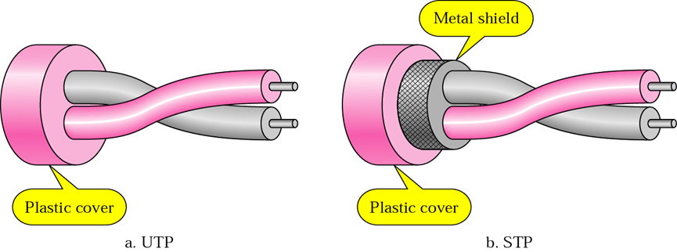

What “twisted pair” means
- Two copper conductors twisted together
- Purpose:
  - Reduce electromagnetic interference (EMI)
  - Reduce crosstalk
- Used for:
  - Data transmission
  - Voice transmission
- Twisting improves:
  - Signal consistency
  - Noise resistance

🔹 Unshielded Twisted Pair (UTP)
- Most common networking cable
- No additional shielding
- Advantages:
  - Lightweight
  - Flexible
  - Smaller diameter
  - Easier installation
  - Lower cost
- Disadvantages:
  - More susceptible to EMI and noise
  - Signal degradation in high-interference environments
Best used in:
Homes, offices, standard LANs where EMI is minimal

🔹 Shielded Twisted Pair (STP)
- Includes shielding made of:
  - Copper tape
  - Conductive polymer
  - Braided copper mesh
- Shielding:
  - Absorbs EMI
  - Reduces crosstalk
  - Improves signal quality
- Advantages:
  - More stable connections
  - Better performance in noisy environments
- Disadvantages:
  - More expensive
  - Bulkier
  - Harder to install
Best used in:
Industrial environments, data centers, areas with heavy EMI

🧠 CAT Cable Categories (Speed, Distance, Frequency)

CAT 5
- Speed: 100 Mbps
- Distance: 100 meters
- Frequency: 100 MHz
- Also called: 100BASE-T (Fast Ethernet)

CAT 5e (Enhanced)
- Speed: 1 Gbps (1000 Mbps)
- Distance: 100 meters
- Frequency: 100 MHz
- Improved twisting reduces crosstalk
- Also called: 1000BASE-T (Gigabit Ethernet)

CAT 6
- 1 Gbps @ 100 meters
- 10 Gbps @ 55 meters
- Frequency: 250 MHz
- Names:
  - 1000BASE-T (at 100 m)
  - 10GBASE-T (≤ 55 m)

CAT 6a (Augmented)
- Speed: 10 Gbps
- Distance: 100 meters
- Frequency: 500 MHz
- Improved crosstalk protection
- Also called: 10GBASE-T

CAT 7
- Speed: 10 Gbps
- Distance: 100 meters
- Frequency: 600 MHz
- Not officially recognized by TIA/EIA
- Still widely used
- Supports 10GBASE-T

CAT 8
- Speed: 25–40 Gbps
- Distance: 30 meters max
- Frequency: 2000 MHz (2 GHz)
- Designed for:
  - Data centers
  - Server-to-server
  - Rack-to-rack connections

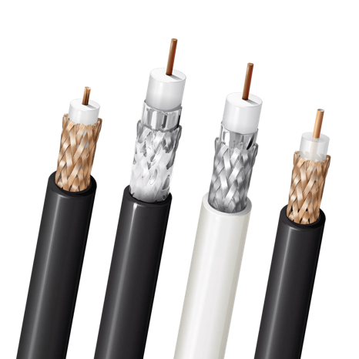
📡 Coaxial Cables
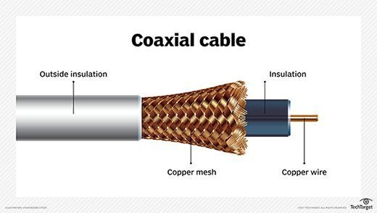

Structure
- Single copper core
- Insulating layer
- Conductive shield

RG-6
- Thicker copper core
- Higher bandwidth
- Used for:
  - Cable modems
  - Broadband internet
  - Digital TV
- Speed: up to 1 Gbps
- Distance: up to 300 meters

RG-59
- Thinner core
- Lower bandwidth
- Used for:
  - Analog video
  - CCTV
- Largely obsolete

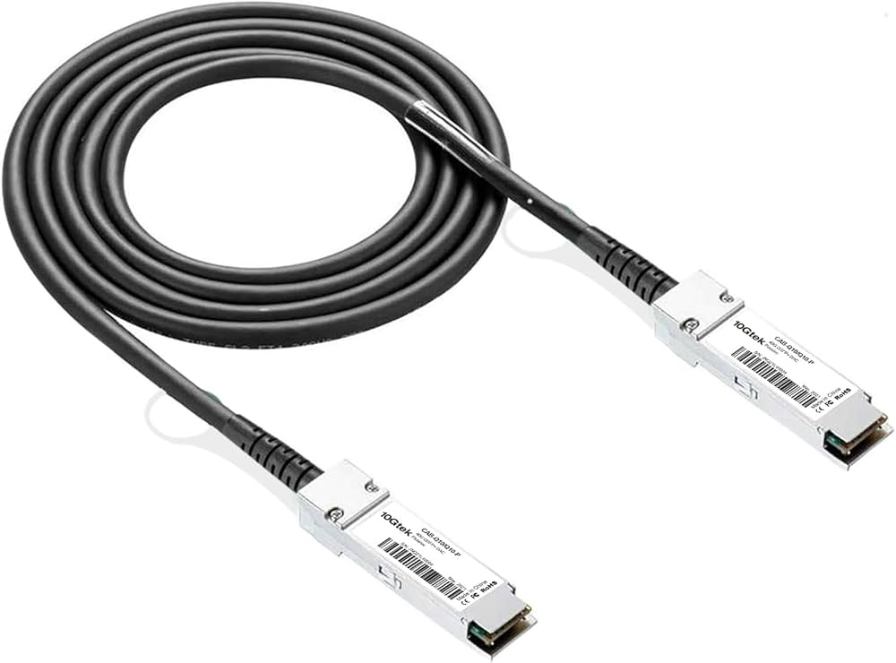
🔗 Direct Attach Copper (DAC)
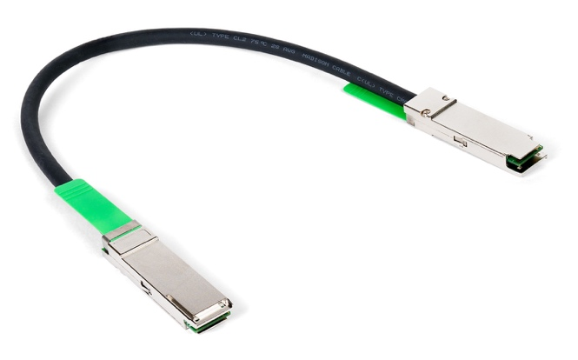

- Pre-terminated copper assemblies
- Used inside:
  - Server racks
  - Data centers
- Connects:
  - Switches
  - Routers
  - Firewalls
  - Servers
- Advantages:
  - Lower cost than fiber
  - Lower power consumption
  - High speed at short distances

Speeds & Distances
- Passive DAC
  - Up to 100 Gbps
  - Max 7 meters
- Active DAC
  - Up to 100 Gbps
  - Max 15 meters
- Common speeds:
  - 10 Gbps
  - 40 Gbps
  - 100 Gbps

🧷 Twinaxial Cables
- Two insulated copper conductors
- Shared outer shield
- Used for:
  - Differential signaling
  - High-speed short-range links
- Common with:
  - SFP+
  - QSFP
- Advantages:
  - High signal integrity
  - Low EMI susceptibility
- Speeds & distances:
  - 10 Gbps → up to 100 m
  - 100 Gbps → ~7 m

🔥 Plenum vs Non-Plenum Cables

Plenum-Rated
- Jacket materials:
  - PVC
  - FEP
- Fire resistant
- Low smoke & toxicity
- Required in:
  - HVAC air-return spaces
  - Plenum areas
- Meets:
  - National Fire Protection Association (NFPA)
  - National Electrical Code (NEC)
- ❌ More expensive

Non-Plenum
- Less fire resistant
- Produces more smoke/toxic fumes
- Used in:
  - Walls
  - Conduit
  - Non-airflow spaces
- ✔ More economical

🧩 Final Classification Logic (Exam Thinking)
- Twisted Pair
  - UTP or STP
  - CAT 5 → CAT 8
  - Plenum or Non-Plenum
- Coaxial
  - RG-6
  - RG-59
  - DAC
  - Twinaxial

🧠 Speed & Distance Master List (Memorize)
- CAT 5: 100 Mbps / 100 m
- CAT 5e: 1 Gbps / 100 m
- CAT 6: 1 Gbps / 100 m → 10 Gbps / 55 m
- CAT 6a: 10 Gbps / 100 m
- CAT 7: 10 Gbps / 100 m
- CAT 8: 25–40 Gbps / 30 m
- RG-6: 1 Gbps / 300 m
- Twinax: 10–100 Gbps / very short range
- DAC: Up to 100 Gbps / 7–15 m

✅ Key Takeaway
Even though fiber is growing, copper media remains critical because it is:
- Cheaper
- Easier to install
- Easier to maintain
- Extremely versatile

Cable Type | Max Speed | Max Distance | Frequency
CAT 5 | 100 Mbps | 100 m | 100 MHz
CAT 5e | 1 Gbps | 100 m | 100 MHz
CAT 6 | 1 Gbps | 100 m | 250 MHz
 | 10 Gbps | 55 m | 250 MHz
CAT 6a | 10 Gbps | 100 m | 500 MHz
CAT 7 | 10 Gbps | 100 m | 600 MHz
CAT 8 | 25–40 Gbps | 30 m | 2000 MHz (2 GHz)
RG-6 (Coax) | 1 Gbps | 300 m | Varies (high-frequency RF)
Twinax | 10–100 Gbps | Very short range (≈7–100 m) | Not CAT-rated (varies)
DAC | Up to 100 Gbps | 7–15 m | Not CAT-rated (varies)

🔌 Copper Network Connectors

Types, Standards, and Uses (Enterprise Networks)

📘 Why connectors matter
In enterprise networks, copper cables are used for:
- Voice (telephones)
- Video
- Data (Ethernet)
Even when the same copper cable is used, the connector on the end determines:
- What device it can connect to
- What application it supports
- The size and format of the wall jack
👉 The cable may stay the same — only the connector changes.
Example:
- A Cat 5e cable can:
  - Connect to a telephone using an RJ-11
  - Connect to a computer using an RJ-45

🧩 Connector naming systems
There are two major connector classification systems you’ll see:

1️⃣ RJ-X (Registered Jack)
- Used with twisted-pair copper cables
- “RJ” = Registered Jack
- The number (X) identifies:
  - Connector size
  - Pin layout
  - Wiring configuration
Examples:
- RJ-11
- RJ-45
As a network technician, RJ-11 and RJ-45 are the most important.

2️⃣ RG-X (Radio Guide)
- Used with coaxial cables
- “RG” = Radio Guide
- Identifies cable type and characteristics
Common RG standards you’ll encounter:
- RG-6
- RG-59
Used for:
- Cable TV
- Cable internet
- Radio and video transmission

📞 RJ-11 Connector

Purpose
- Standard connector for telephone wiring
- Connects phones to wall jacks

Technical details
- 6P2C (6 positions, 2 conductors)
  - Connector has space for 6 pins
  - Only 2 pins are typically used

Characteristics
- Small size
- Designed for voice signals
- Uses only a few internal wires

Limitations
- ❌ Not suitable for high-speed data
- ❌ Cannot support Ethernet speeds

Used for
- Landline telephones
- Voice-only communication networks

🌐 RJ-45 Connector

Purpose
- Standard connector for Ethernet data networks

Technical details
- 8P8C (8 positions, 8 conductors)
- Uses all wire pairs in the cable

Characteristics
- Larger than RJ-11
- Supports high bandwidth
- Required for modern Ethernet

Compatible cables
- Cat 5
- Cat 5e
- Cat 6
- Cat 6a
- Cat 7
- Cat 8

Used for
- Computers
- Switches
- Routers
- Network printers
- VoIP phones
👉 RJ-45 is the de facto standard for copper Ethernet networks in homes and enterprises.

📺 F-Type Connector (Coaxial)

Purpose
- Standard connector for coaxial cables
- Screw-on design

Used with
- RG-6
- RG-59

Common applications
- Cable television
- Satellite TV
- Cable internet (modems)

RG-6 Cable (Modern Standard)
Construction
- Single copper core
- Insulating layer
- Metallic shield
- Outer protective jacket
Advantages
- Thicker gauge
- Better shielding
- Higher bandwidth
- Higher frequency support
- Less signal loss over distance
Used for
- Digital TV
- Cable modems
- High-speed internet

RG-59 Cable (Older Standard)
Characteristics
- Thinner core
- Lower bandwidth
- Lower frequency capability
Current usage
- Largely replaced by RG-6
- Still found in:
  - CCTV systems
  - Older analog video installations
⚠️ Never use RG-59 for high-definition or high-bandwidth applications

🎥 BNC Connector

Full name
- Bayonet Neill-Concelman

Connector type
- Coaxial
- Push-and-twist locking mechanism
- Quarter-turn bayonet lock

Used with
- RG-6
- RG-59

Characteristics
- Very secure connection
- Fast to connect and disconnect
- Reliable signal integrity

Common applications
- Professional video equipment
- Video surveillance systems
- Radio frequency (RF) systems
- Studio environments

BNC name confusion (exam note)
Many people incorrectly call BNC:
- ❌ “British Naval Connector”
Correct name:
- ✅ Bayonet Neill-Concelman
The confusion comes from:
- Its early use on British Navy radio equipment in the 1940s
👉 On the exam, BNC = Bayonet Neill-Concelman.

🧠 Summary Table (Quick Review)
Connector | Cable Type | Used For
RJ-11 | Twisted pair | Telephones / Voice
RJ-45 | Twisted pair | Ethernet / Data
F-Type | Coaxial (RG-6 / RG-59) | Cable TV, Cable Internet
BNC | Coaxial (RG-6 / RG-59) | Professional video, CCTV

✅ Key Takeaways (Exam-Ready)
- Cable ≠ Connector
Same cable, different connector → different application
- RJ-11 = voice
- RJ-45 = Ethernet data
- RG-6 > RG-59 for modern coax applications
- F-type = screw-on coax
- BNC = push-and-twist coax

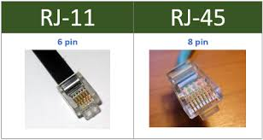
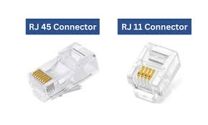

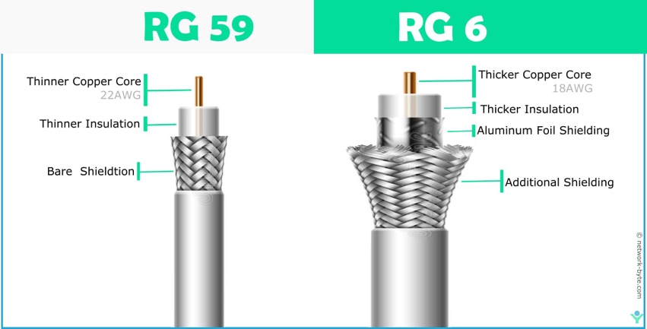
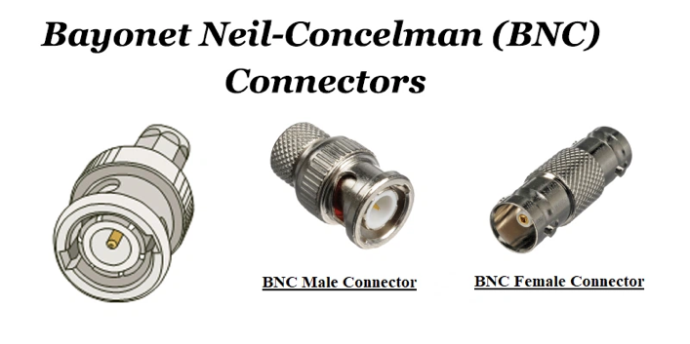

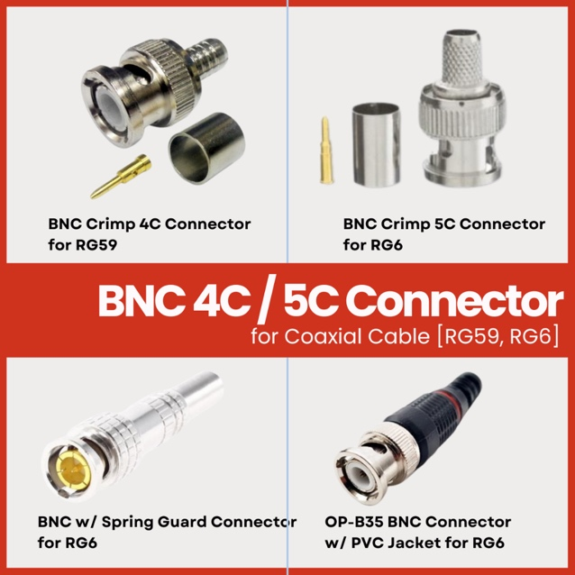

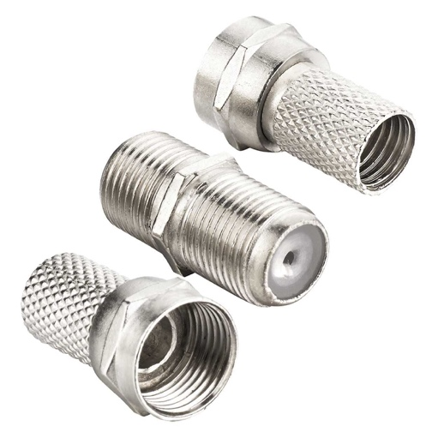

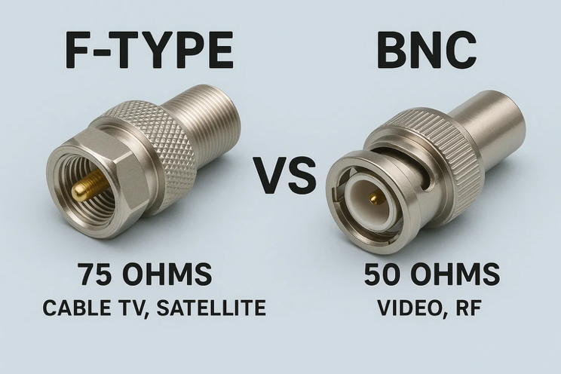

🔧 Wiring Copper Cables & Ethernet Pinouts
Now that we’ve covered cable types, categories, and connectors, the next step is understanding how cables are wired into those connectors. This includes knowing pinouts, straight-through cables, crossover cables, and the tools used to build and test them.
This topic is fair game on the exam, especially because one of the objectives requires you to troubleshoot common cable connectivity issues using tools such as:
- Cable stripper
- Cable crimper
- Cable tester
You may see simulation-based questions that ask you to wire a cable correctly or identify the correct pinout.

🔌 Straight-Through (Patch) Cables
A straight-through cable, also called a patch cable, has:
- The same pinout on both ends
- Pin 1 on one end → Pin 1 on the other end
- Pin 2 → Pin 2, and so on
This is why it’s called straight-through.

Common Standard Used
- T568B → T568B
- This is the preferred standard for:
  - Interior wiring
  - Patch cables
  - Wall jacks

T568B Pin Order (Pins 1–8)
- White/Orange
- Orange
- White/Green
- Blue
- White/Blue
- Green
- White/Brown
- Brown
Both ends are wired identically.

🖥️ DTE vs DCE (Important Exam Concept)

DTE – Data Terminal Equipment
Endpoint devices such as:
- Laptops
- Desktops
- Servers
- Routers

DCE – Data Communications Equipment
Network infrastructure devices such as:
- Switches
- Modems
- Hubs
- Bridges

Rule to Remember
- DTE ↔ DCE → Straight-through cable
- DTE ↔ DTE → Crossover cable
- DCE ↔ DCE → Crossover cable
Example:
- Computer → Switch → Straight-through
- Switch → Switch → Crossover
- Computer → Computer → Crossover

🔁 Crossover Cables
A crossover cable swaps the transmit and receive pairs.

How it’s wired
- One end: T568B
- Other end: T568A
This swaps:
- Pins 1, 2, 3, and 6
- The orange and green pairs

Used for
- Workstation → Workstation
- Switch → Switch
- Any same-type device connection

⚠️ MDIX (Important Exam Warning)
Most modern switches support MDIX, which:
- Automatically detects cable type
- Internally swaps transmit/receive pins
- Allows straight-through cables to work like crossover cables

BUT for the exam:
- Assume switches do NOT support MDIX
- Unless the question explicitly says MDIX is supported
👉 On the exam: Switch ↔ Switch = crossover cable

📐 T568A vs T568B (Pinout Standards)
- T568B
  - Preferred for building wiring
  - Used on both ends of straight-through cables
- T568A
  - Used on one end of a crossover cable

Key difference
- Orange and green pairs are swapped between A and B
⚠️ Yes, you must memorize this for the exam
In the real world you can look it up — on the exam, you cannot.

🧰 Tools Used to Make Ethernet Cables

Cable Stripper
- Removes the outer sheath
- Exposes the inner twisted pairs

Crimper (RJ-45)
- Cuts the cable
- Pushes wires into connector pins
- Locks the connector in place
Crimpers usually support:
- 8-pin (RJ-45)
- 6-pin (RJ-11)
- 4-pin (rarely used)

RJ-45 Connectors
- Plastic connectors attached to each cable end
- Required to plug into switches, PCs, or patch panels

Cable Tester
- Verifies correct pin connections
- Confirms:
  - Straight-through (1→1, 2→2, etc.)
  - Crossover (swapped pairs)
- Detects opens, shorts, and miswires

🔨 Cable Creation Process (Conceptual)
- Start with bulk twisted-pair cable
- Strip the outer jacket
- Untwist and straighten the wire pairs
- Arrange wires in correct color order
- Trim excess wire
- Insert into RJ-45 connector
- Crimp the connector
- Repeat on the other end
- Test the cable

🧪 Testing the Cable
- Plug each end into the cable tester
- Power on the tester
- Verify:
  - Straight-through: pin numbers match
  - Crossover: transmit/receive pins swap correctly
If the pin order matches expectations → cable is good

🧠 Exam Reality vs Real World

Exam
- You may be asked to:
  - Identify straight-through vs crossover
  - Drag-and-drop colored wires into correct pins
  - Choose the correct cable type for devices

Real World
- Most patch cables are pre-made
- Custom cables are used mainly for:
  - Odd lengths
  - Permanent installations

📏 Cable Length Rule (Very Important)
- Maximum Ethernet cable length: 100 meters
- Best practice:
  - Stay under 90 meters
  - Allows room for patch cables and slack
- Longer runs cause signal degradation

✅ Key Exam Takeaways
- Straight-through = same pinout on both ends
- Crossover = T568A on one end, T568B on the other
- Switch ↔ Switch → crossover (unless MDIX is stated)
- Memorize T568B color order
- Cable length limit = 100 meters

